**Library Management System**

**User Instructions:-**

* Navigate to the link :- http://<IPAddress>:8080/Library02/Home.jsp
* Home page will have 4 buttons(3 buttons with self explanatory pictures and one with description) for each operations(Search, Check-In Check-Out, User Management, Fine Processing).Clicking on each button will guide the user through messages(along with error messages) to perform each functionality. Below are the screenshots for each page in the application.

**Homepage**

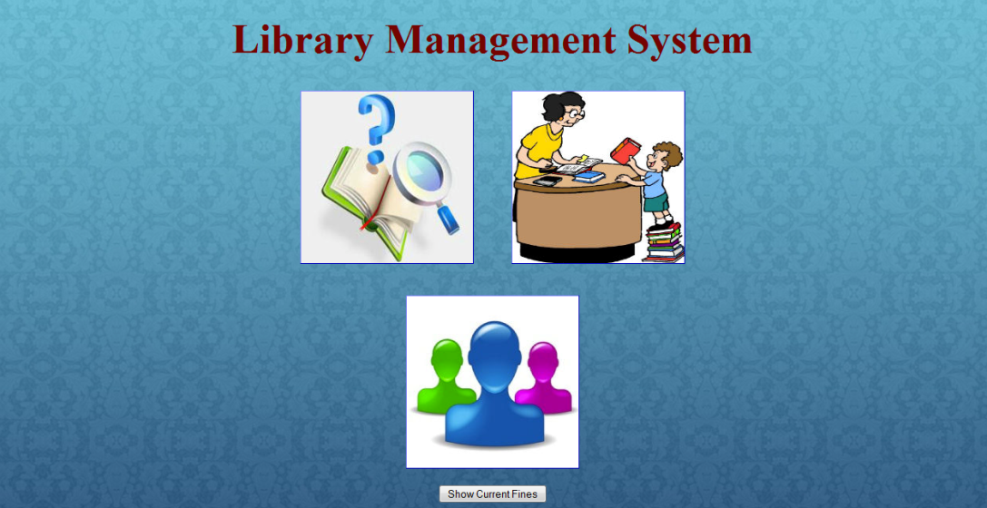

**Search Page**

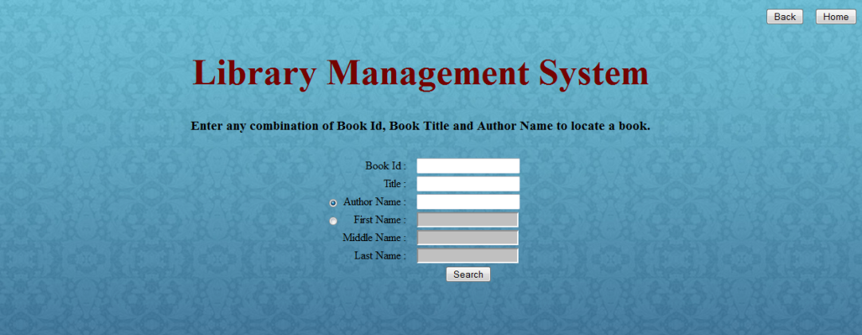

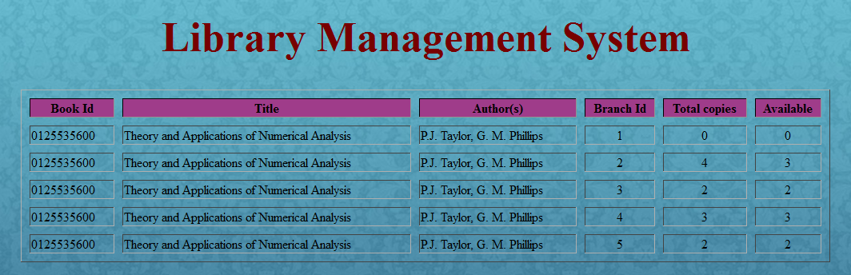

**Check-in and Check-out Section**

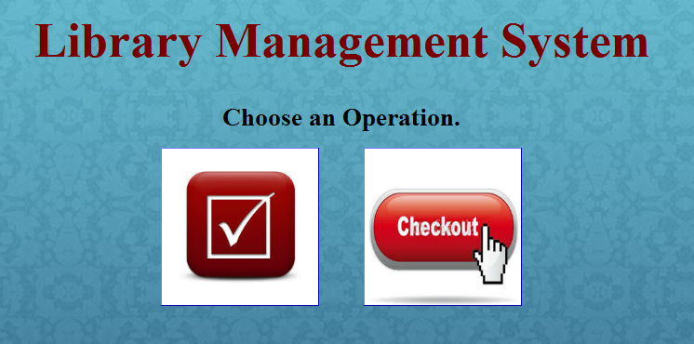

**Book Check-out**



**Book Check-in**

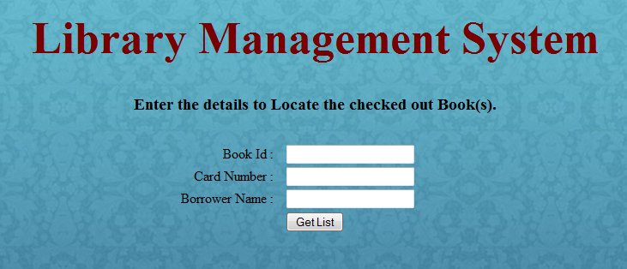

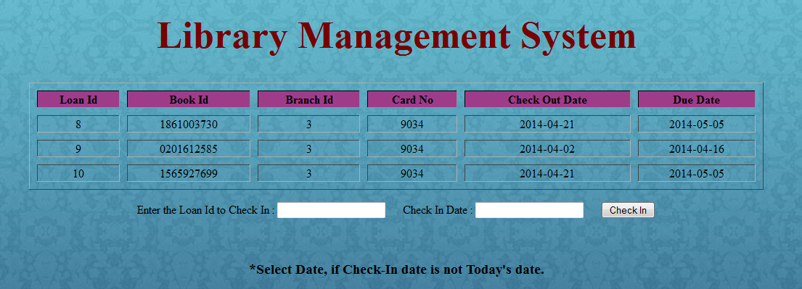

**User Management Section**

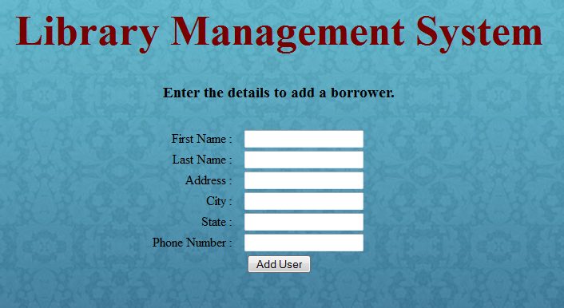

**Fine Processing Section**

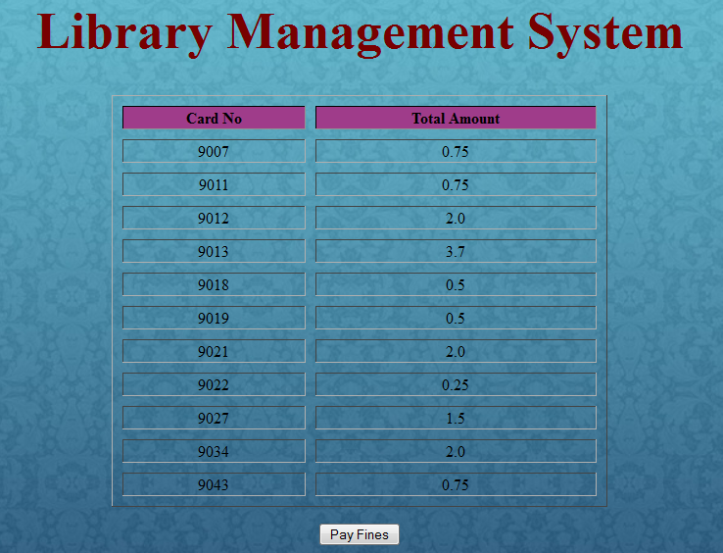

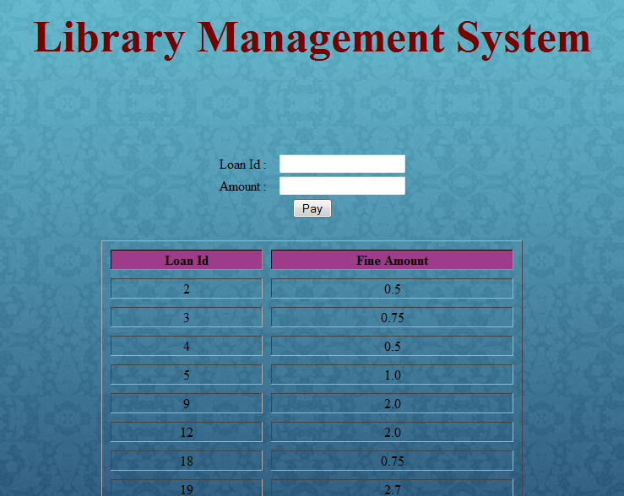

**Design Decisions:-**

1. **Layered Architecture :-** 
   * JSP has been used for presentation and control flow where as java has been used for business logic development.
   * Any changes to business logic can be accommodated without making any changes to presentation and control flow logic.
   * Layered architecture also has helped to test application completely independent of GUI.
2. **Modular Design(Business logic):-**
   * The complete work flow was developed in four different modules independent of each other.

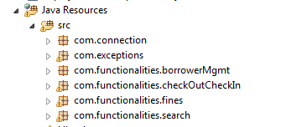

* + Custom Exceptions have been used to handle different exceptions with proper error messages.
  + Connection class has been made singleton so that only one instance of connection will be used for any workflow and the opened connection will closed properly and there won’t be any connections left in open state.

1. **Database Changes :-**
   * A new attribute “available_copies” has been added to the schema “book_copies” to keep track of available copies of books at each branch after any check-in/check-out operation.
   * A new attribute “no_of_books_taken” has been added to the schema “borrower” to keep track of no of books taken by each user after any check-in/check-out operation.

**Technical Dependencies:-**

* Technologies used :- **JAVA (JDK 1.6)**, **JSP**, **Apache Tomcat v6.0 , jQuery (For DatePickr), MySQL**
* Libraries used :- **mysql-connector-java-5.1.29-bin.jar** (For JDBC)